

**World Assembly of Youth**

**12th Melaka International Youth Dialogue**

**“Health, It’s My Right”, 28th – 30th June, 2012**

**Day 1**

After riding the bus for 10 hours I finally arrived in Melaka. Upon arrival there was some confusion since the volunteers registered me as a guest speaker. That mistake was corrected immediately when I found out! Later that evening I attended the ice breaking session and was a bit disappointed in the turnout. I quickly found myself the only Western person attending the conference aside from a German guest speaker. This was to become a bit of a challenge but also a very positive experience for me.

**Day 2**

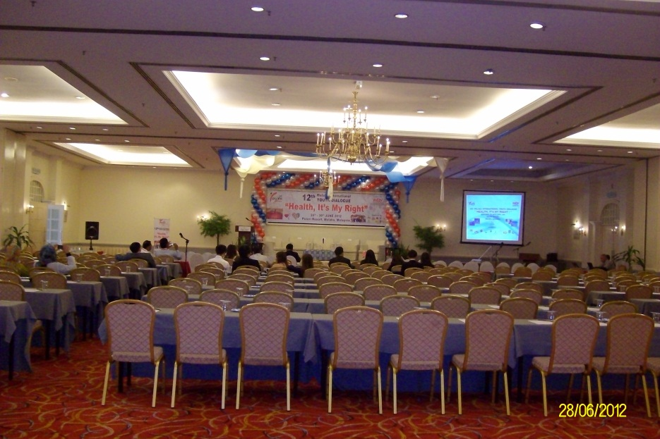

The opening ceremony took place and lasted for a very long time. This would be my first encounter with Asian protocol and I found myself a bit amused by all the clapping and appreciation of each other. More participants had now arrived and the hotel ballroom was close to full. The speeches given by the WAY President and the Minister of Health were very general and not inspiring. They seemed afraid to address the issue of youth health by directly mentioning the factors such as HIV/AIDS and sexual health which has great influence on the topic.

Most of the speeches during the plenary session were excellent, inspirational and touching. However, there were 12 of them! Very tiring and the speakers had trouble keeping the attention of the audience. Among my favorites was Dr. Marco Roncarati from UNESCAP who presented his perception of health from a more holistic point of view. He made us think of how important it is to nurture the trinity of body, mind and soul in order to be healthy. The presentation giving by Mr. Rinaldi Ridwan on the importance of providing children and youth with comprehensive sexual education was liberating. Finally a guest speaker who was not afraid to talk freely about touchy subjects such as homosexuality, sex before marriage and abortion. This was needed to make us all confident enough to raise these issues later on. Dr. André Mueller made us all wake up with a fantastic presentation on the importance of physical activity in relation to health and how gender plays a major role on access, time and expectations towards being physically active.

Some guest speakers used the opportunity to ramble on about their view on health, society, the world and youth of today and what have you not. I found some of the speakers simply too old to deserve a seat as a guest speaker. Their views were out of date and in many ways they were unable to relate to the audience. I was frustrated that within their presentations you would see and hear views, programs and ideas that were simply wrong, outdated or narrow minded. Dr. Nik Rashid from the Ministry of Health shortly mentioned a program called “No Apologies – no sex before marriage” but enough to rub me the wrong way. It is narrow minded programs like this that have no effect on the increasing rates of abortion and baby dumping in Malaysia. I approached later on and she clarified that the program does in fact educate youth on contraceptives and their use. But this was not mentioned on stage. A speaker mentioned that contraceptives are for older women and another one told us that they teach couples how to avoid having sex. When approached afterwards the intention of their words was quite different but in a forum where the majority comes from backgrounds with many restrictions the speakers should broaden the horizon of the audience and not glorify traditions. We were there to make a change in the mindset of society.

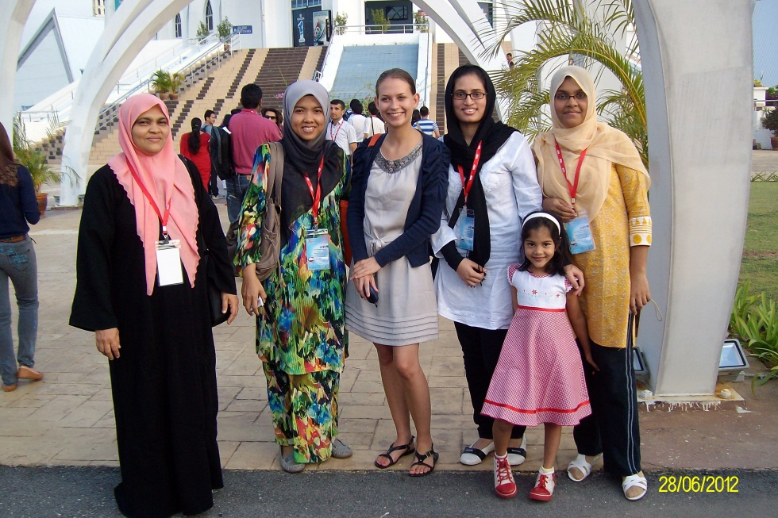

The plenary session ended in a discussion on the definition of youth. Again, the dinosaurs on stage handled this very badly and to gather their points of views they believed that you are not an adult until you have finished your education and experienced the responsibilities of marriage. In my opinion, that was a fine way of insulting the intelligence and level of responsibility of the participants whose ages ranged from 18-30.

**Day 3**

The day started with divided all participants into groups of 8-10 people. My group consisted of participants from India, Sri Lanka, Bangladesh, Egypt, Botswana, Malaysia and the Maldives. Our guidelines were to discuss the role of stakeholders on youth health. The identified stakeholders were the public and private sector, NGO’s, media and education. We were asked to elect a group leader and a secretary. The group leader was to present our recommendations to the conference at the end of the day. Our discussions covered many aspects of the different stakeholders and their roles. I would let everybody voice their view on different aspects and I often found myself explaining how the aspects are handled in Denmark. They were very interested and found my country context an important source of inspiration for how things could be. My contribution to our group was therefore to provide small eye-openers whenever the discussion had reached a dead end and our final recommendations were inspired by the Danish society. The recommendations may have been unrealistic to achieve in many countries but they are what we as youth and the future generation want from our society.

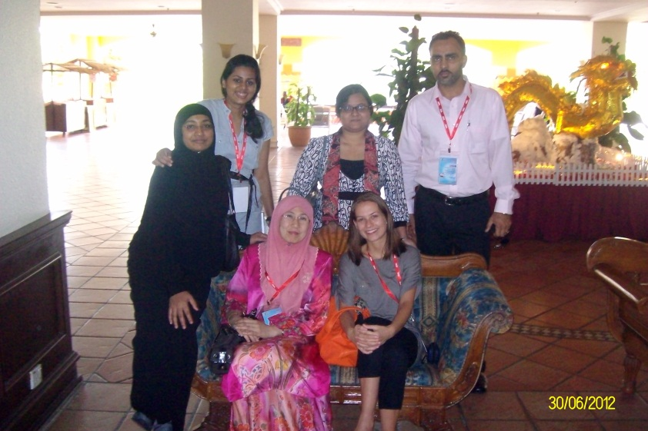

From our recent experiences with the bad time management of the staff, it came as a huge surprise when we were called to present our recommendations on the exact hour and as the first group. I managed to present without any notes and with a Power Point only half done. I felt quite proud of myself afterwards.

Later that evening the group leaders and secretaries were asked to join in on the Drafting Committee meeting. What we were all unaware of due to inadequate communication was that we in fact were the Drafting Committee. So sleep deprived from talking and meeting new people the day before, I was now set to formulate the entire declaration together with 20 other more or less willing participants. The fact that we were not prepared for this, many fell asleep during the night and others were not contributing despite their presentation earlier on. The declaration was put together by about 10 people and the last word was formulated at 7.30 in the morning. It was my goal for the declaration to include a recommendation for the public sector to ensure a minimum of six months of maternity leave to achieve the WHO recommendations for exclusive breastfeeding. This was met with hesitation and after some heavy discussion the compromise was to include a section on the rights to paternity and maternity leave. It was impossible for me to convince them of including breastfeeding. Due to this, and the consistence of using the term of health issue instead of specifying it as HIV/AIDS, sexual education, gay/straight and so on, I find the declaration to be very broad and vague. After the Drafting Committee meeting it was quite clear to me that the World Assembly of Youth is afraid to be too outspoken, provocative and uncensored. In my opinion however, that is the only way to draw attention to an urgent matter and it is because of this vague attitude that things are not moving forward faster.

After a few hours of sleep the 12th MIYD Declaration on Youth Health was presented and adopted without much alteration from the other participants.

I attended the Gala Dinner completely exhausted but went to sleep when the sun rose full of new impression, changed perceptions and the promise of new friends from around the world.

